**UCSC312P-MACHINE-LEARNING- BSC/BCA STUDENTS**

**LAB EXERCISE PROGRAMS**

**ASSESSMENT - 1**

**23BCA0092**

**SAKTHIVEL.M**

**Basic Python Program**

1. **Write a python program to find out input string is palindrome or not using function**

**PROGRAM:**

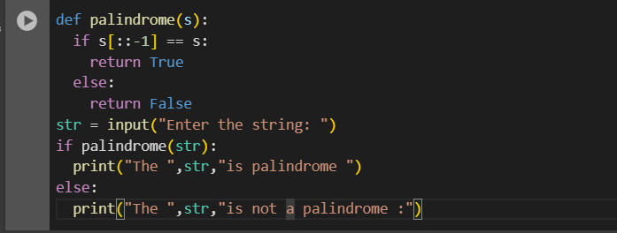

**OUTPUT:**

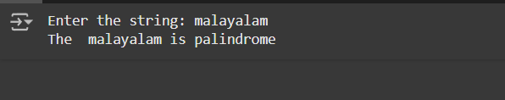

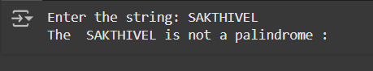

**2. Write a python program using if statements that will determine the result of a rock, paper, scissors game, given Player 1 and Player 2’s choices. Your program will print out the result. Here are the rules**

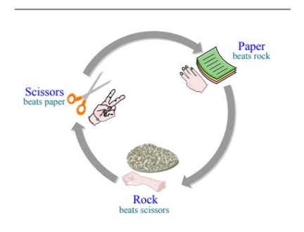**of the game: a. First create a truth table for all the possible choices for player 1 and 2, and the outcome of the game. This will help you figure out how to code the game. b. Create a new file that will generate the outcome of the rock, scissors, paper game. The program should ask the user for input and display the answer as follows: Player 1? rock Player 2? scissors Player 1 wins. The only valid inputs are rock, paper, and scissors. If the user enters anything else, your program should output “This is not a valid object selection”.**

**TRUTH TABLE**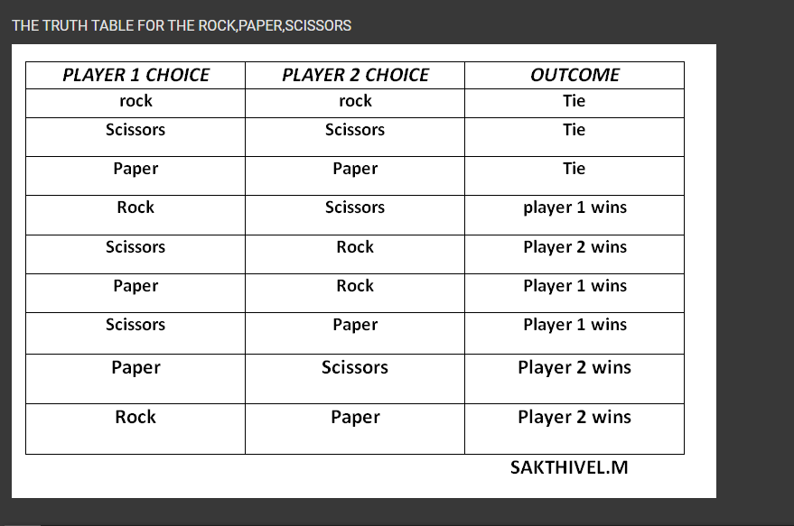

**PROGRAM:**

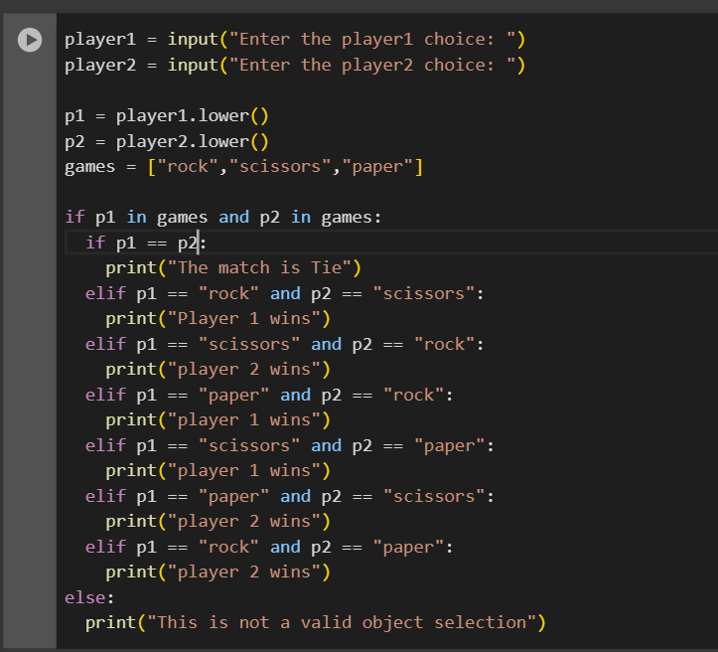

**OUTPUT:**

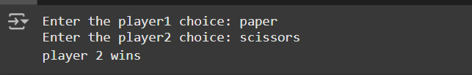

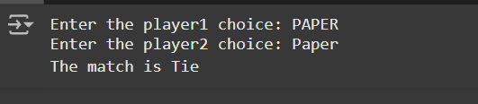

**3. Write a program that defines and calls functions to calculate the factorial of a number.**

**PROGRAM:**

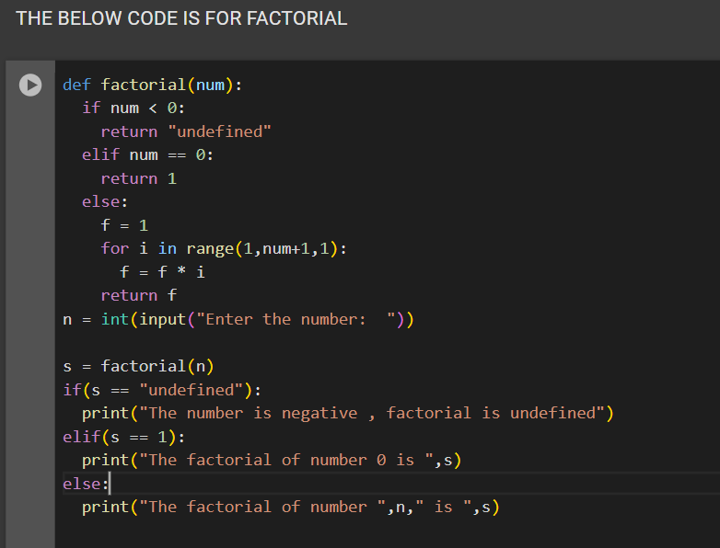

**OUTPUT:**

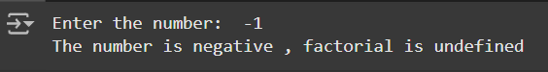

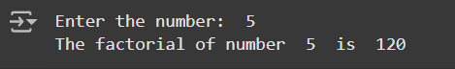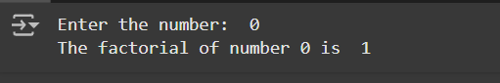

**4. Implement a function that takes a list of numbers as input and returns the average.**

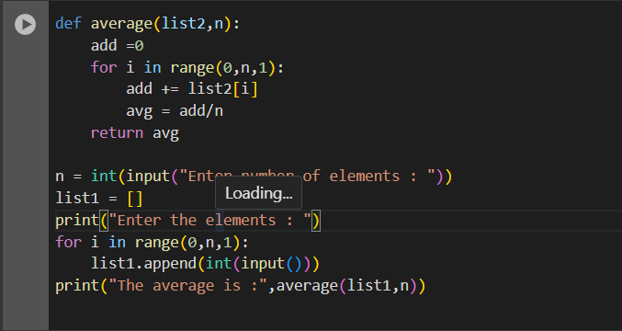

**OUTPUT:**

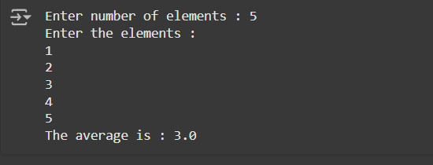

**5. Create a python program to store student names and their scores in a dictionary, and perform operations like adding a new student, updating scores, and finding the highest score.**

**PROGRAM:**

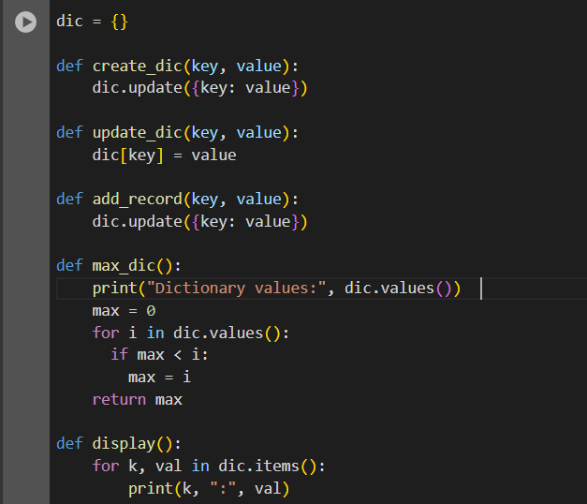

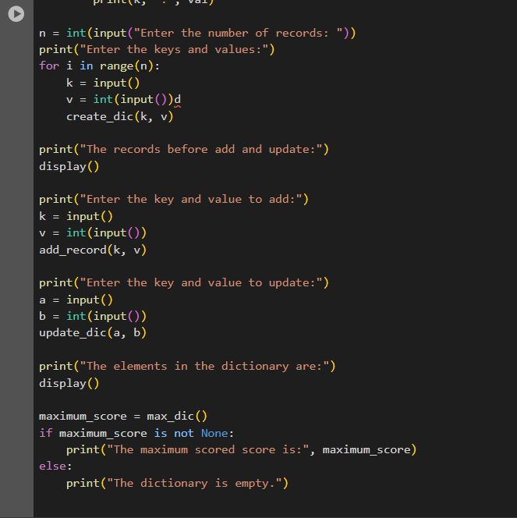

**OUTPUT:**

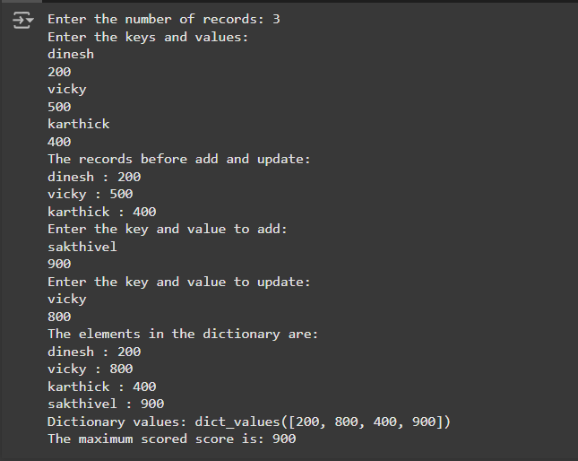

**6. Create a python program to count the number of words in a file.**

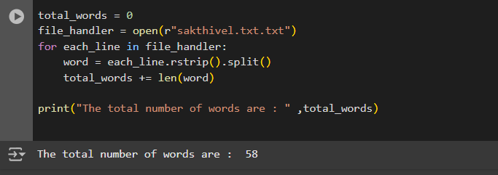

**7. Write a python program to count the number of vowels in a given string.**

**PROGRAM:**

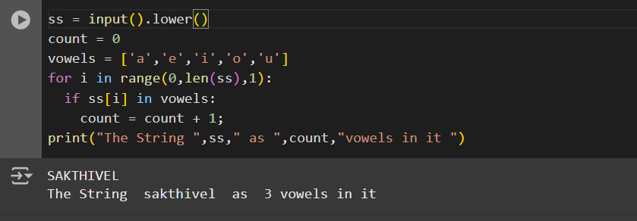

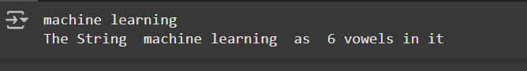

**8. Write a python function to check if a number is prime**

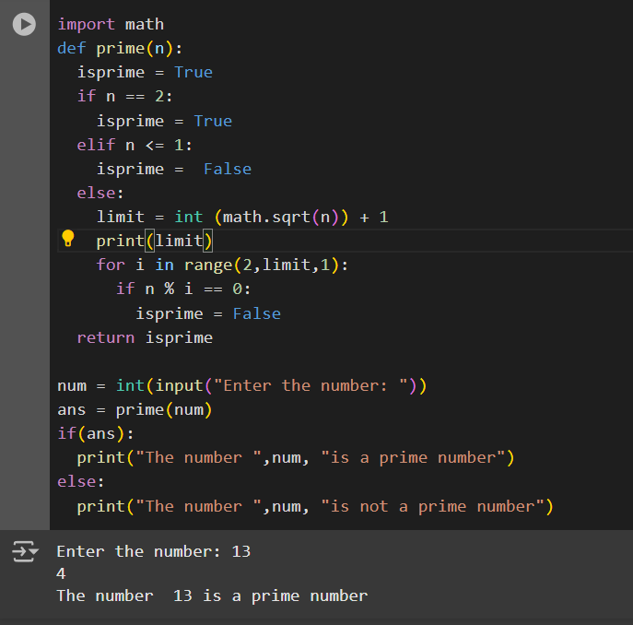

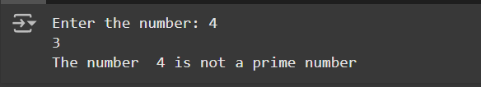

**9. Write a function to generate a random number within a specified range.**

**PROGRAM:**

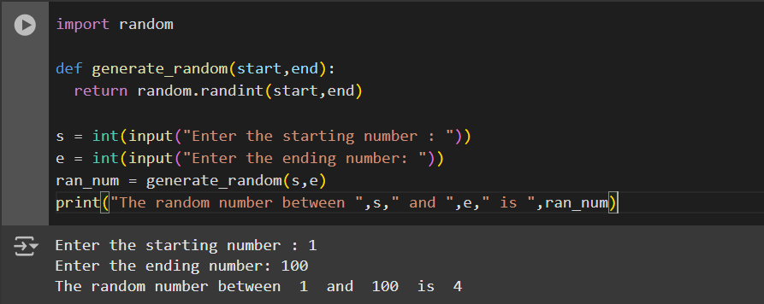

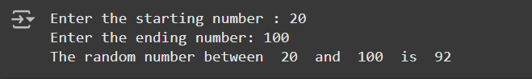

**10. Write a python program to remove all the spaces from a given string**

**PROGRAM:**

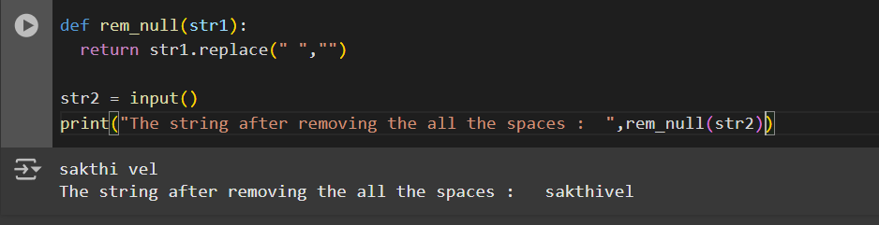

**Cycle -01 – Using NumPy**

1. **Write a python program to find out mean , standard deviation , covariance , eigen vectors , eigen values for the given array using numpy.**

**PROGRAM:**

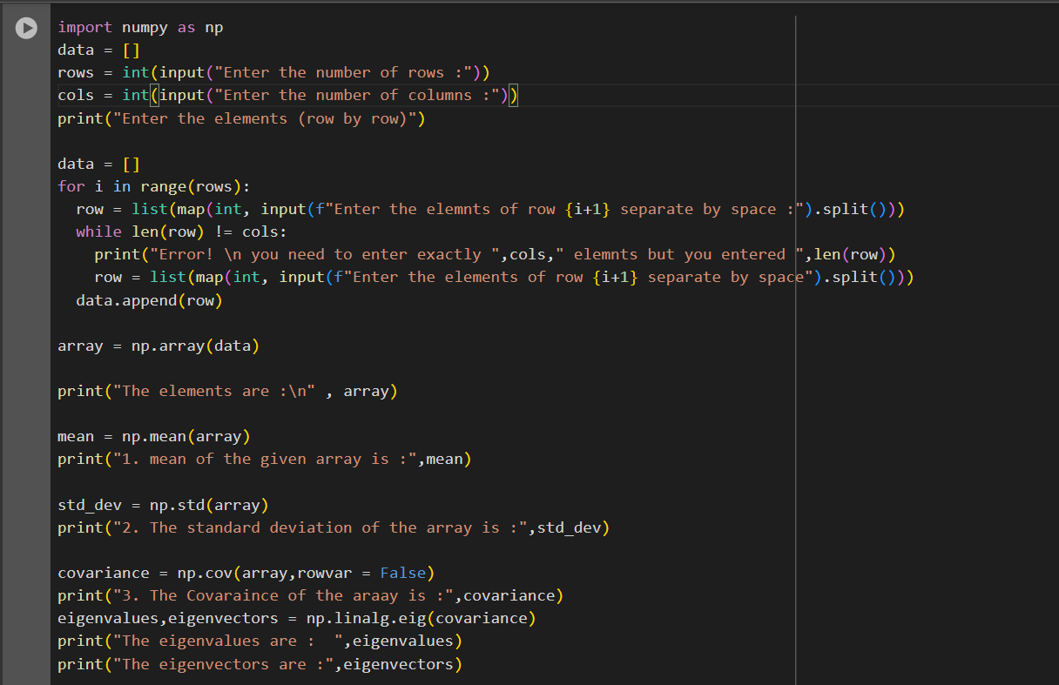

**OUTPUT:**

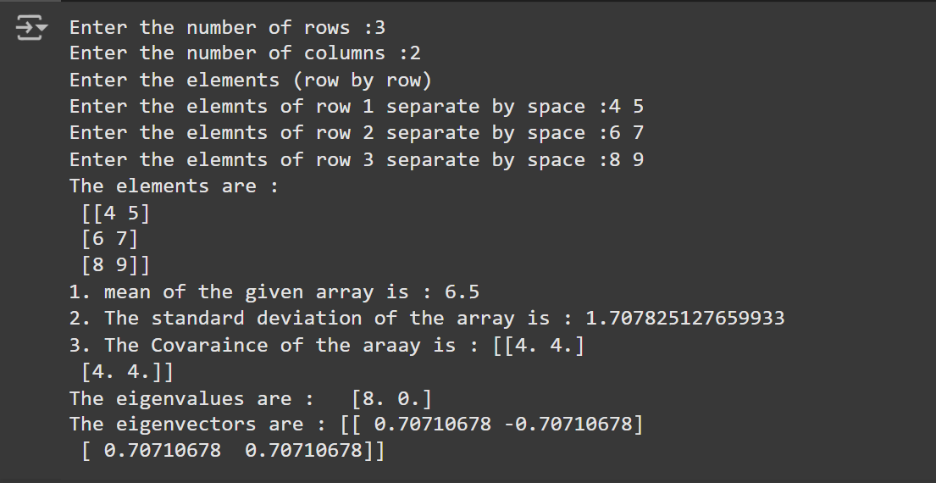

1. **Write a python program to find out non-zero element in a given array (any size) using numpy.**

**PROGRAM:**

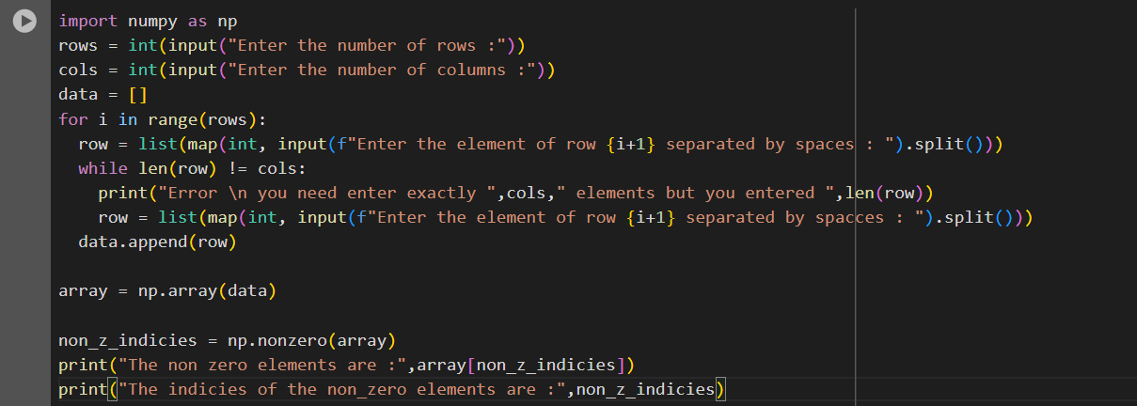

**OUTPUT:**

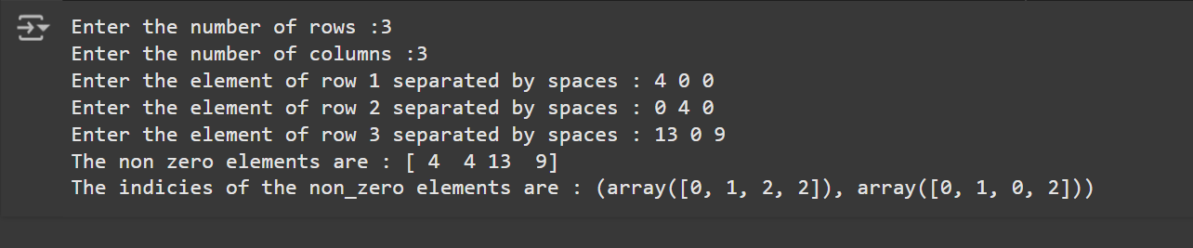

**3.Calculate eigenvalues and eigenvectors of a matrix using Numpy.**

**PROGRAM:**

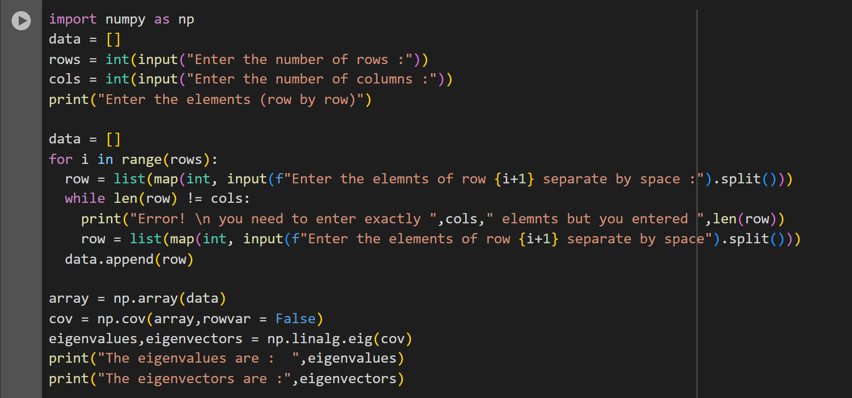

**OUTPUT:**

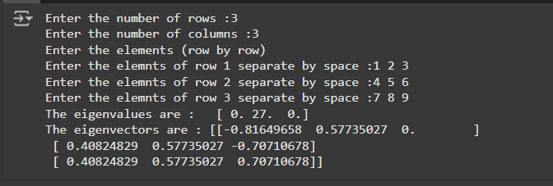

**4.Convert the any image to a NumPy array.**

**PROGRAM:**

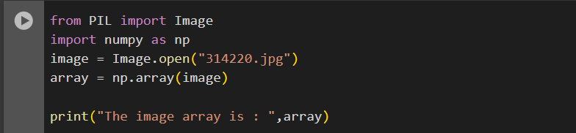

**OUTPUT:**

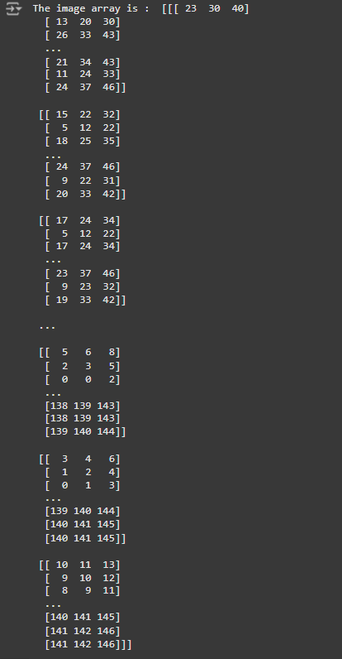

**5. Generate an array of random numbers from a normal distribution using numpy**

**PROGRAM:**

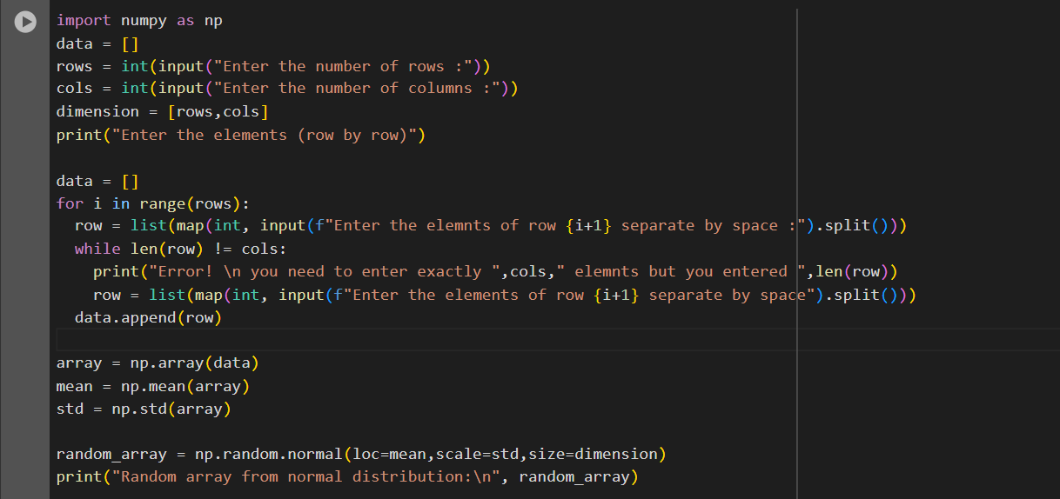

**OUTPUT:**

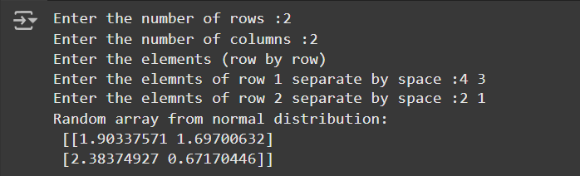

**Cycle -01- Using Matplotlib**

**1.Write a Python program to draw a line and graph with suitable label in the x axis, y axis and a title as in the following image**

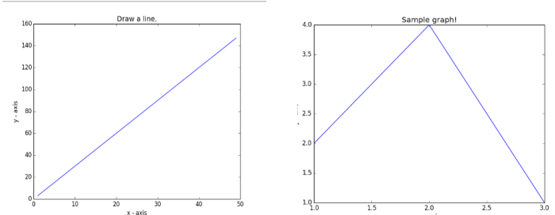

**PROGRAM:**

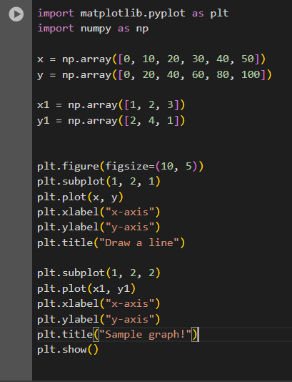

**OUTPUT:**

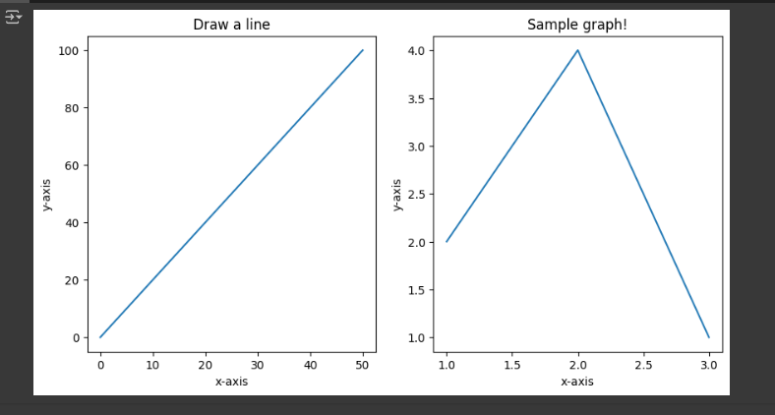

**2. Write a Python programming to display a bar chart of the popularity of programming**

**Languages.**

**Sample data: Programming languages: Java, Python, PHP, JavaScript, C#, C++ ,Popularity: 22.2, 17.6, 8.8, 8, 7.7, 6.7 as in image**

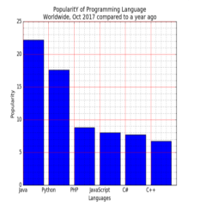

**PROGRAM:**

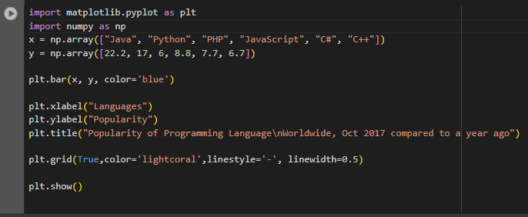

**OUTPUT:**

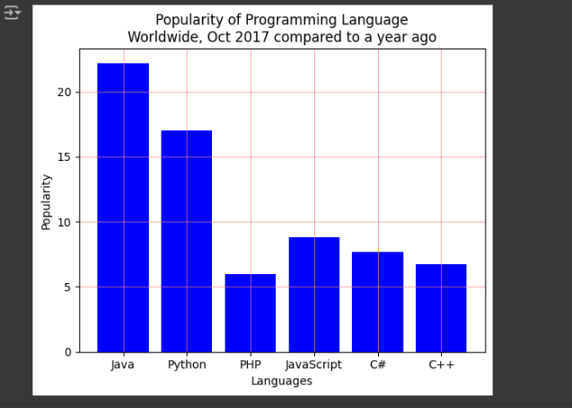

**3. Write a Python programming to create a pie chart of the popularity of programming**

**Languages. Sample data: Programming languages: Java, Python, PHP, JavaScript, C#, C++ ,Popularity: 22.2, 17.6, 8.8, 8, 7.7, 6.7 as in image**

**Program:**

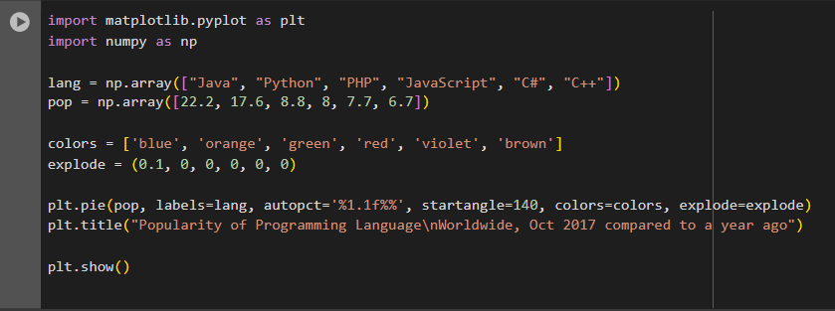

**OUTPUT:**

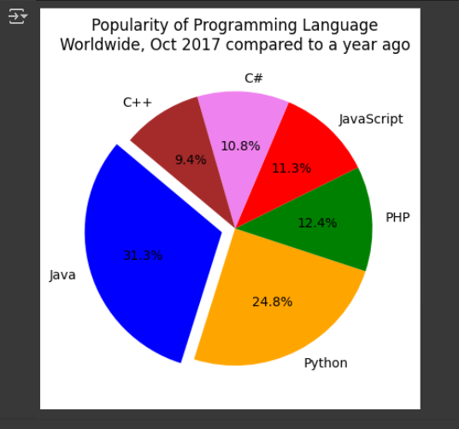

**4. Write a Python program to draw a scatter plot comparing two subject marks of Mathematics**

**and Science. Use marks of 10 students.Sample data:**

**Test Data:**

**math_marks = [88, 92, 80, 89, 100, 80, 60, 100, 80, 34]**

**science_marks = [35, 79, 79, 48, 100, 88, 32, 45, 20, 30]**

**marks_range = [10, 20, 30, 40, 50, 60, 70, 80, 90, 100]**

**PROGRAM:**

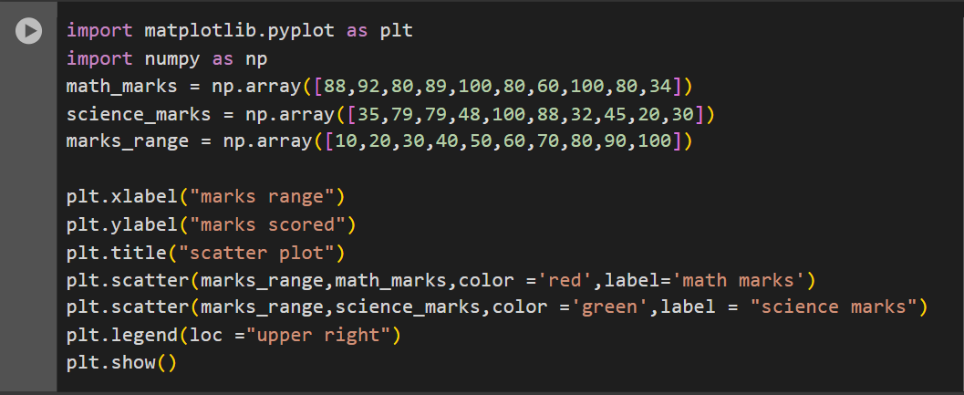

**OUTPUT:**

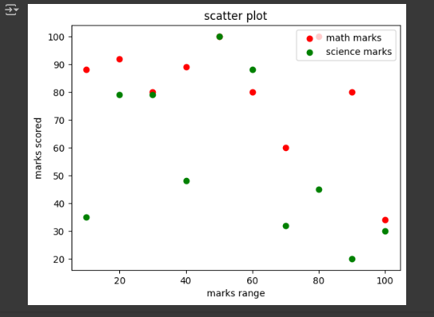

**5. Write a Python program to rotate and zoom in/out on any 3D plots.**

**Cycle -01 – Using Pandas**

1.Write a Pandas program to convert your name as dictionary into a Pandas series.

PROGRAM.

import pandas as pd

name_dic = {

    "name" : "sakthivel"

}

series = pd.Series(name_dic)

print(series)

**OUTPUT:**

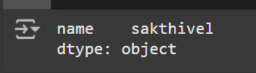

2. Write a Pandas program to convert a NumPy array to a Pandas series

PROGRAM:

import pandas as pd

import numpy as np

arr1 = np.array(["liner regression","logistic regression","k-means","support vector machine","non-linear regression"])

arr_series = pd.Series(arr1)

print(arr_series)

OUTPUT:

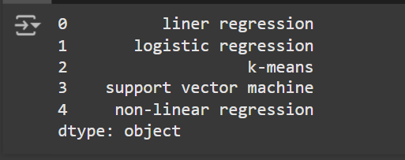

3. Write a Pandas program to create the mean and standard deviation of the data of a given Series

**PROGRAM:**

import pandas as pd

lis = []

n = int(input("Enter the number of elements :"))

for i in range(0,n,1):

  lis.append(int(input()))

data  = pd.Series(lis)

mean = data.mean()

std = data.std()

print("The pandas series is :")

print(data)

print("The mean is :",mean)

print("The std is :",std)

**OUTPUT:**

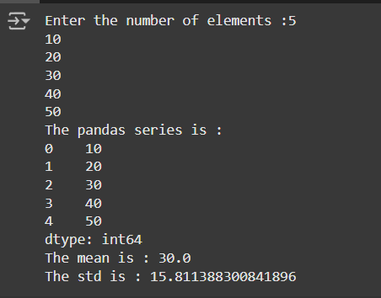

4. Write a Pandas program to import given excel data into a Pandas dataframe . Excel data will

have the following features with 5 records

i. Register Number

ii. Name of Students

iii. No. of Subjects registered in this semester

import pandas as pd

dataset = pd.read_excel('/content/ml_excel.xlsx')

dataframe = pd.DataFrame(dataset)

print("The Excel sheet as dataframe")

print(dataframe)

**OUTPUT:**

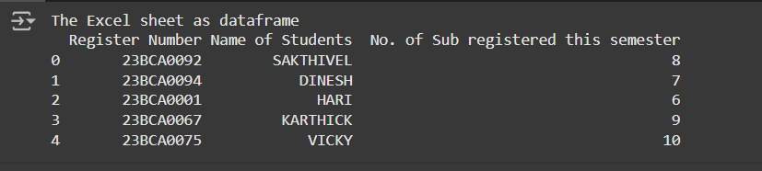

5. Write a Pandas program to import above excel data into a dataframe and find details where "

Register Number " > 10

PROGRAM:

import pandas as pd

# Load the Excel dataset

dataset = pd.read_excel('/content/ml2_excel.xlsx')

# Convert it into a DataFrame

dataframe = pd.DataFrame(dataset)

print("The Excel sheet as dataframe:")

print(dataframe)

print("\nThe details of the register no. > 10:")

print("Register Number\tName of Students\tNo. of Sub registered this semester")

for i in dataset.index:

    if dataset.loc[i, "Register Number"] > 10:

        print(

            dataset.loc[i, "Register Number"],"\t",

            dataset.loc[i, "Name of Students"],"\t\t\t\t\t",

            dataset.loc[i, "No. of Sub registered this semester"]

        )

**OUTPUT:**

